Student Performance Analysis using R Programming

1. Problem Statement
In educational institutions, analyzing student performance manually is time-consuming and error-prone.
This project develops an R-based automated system to:
- Read student marks data
- Perform statistical analysis
- Classify students into grades
- Identify top & low performers
- Visualize results using charts
2. Application
This system is useful for:
- Schools & Colleges
- Coaching Centers
- Online Learning Platforms
Helps in:
- Evaluating performance
- Identifying weak students
- Automating results
- Visualizing academic data
3. Objectives
- Calculate Mean, Median, Standard Deviation
- Compute Total & Average
- Assign Grades (A–F)
- Identify Top 3 Students
- Identify Lowest Performer
- Generate Charts (Bar, Pie, Histogram)
4. Project Structure
StudentMarksAnalysis/
├── data/
│ └── student_marks.csv
├── scripts/
│ ├── 01_load_data.R
│ ├── 02_process_data.R
│ ├── 03_analysis.R
│ ├── 04_visualization.R
├── output/
│ ├── final_results.csv
│ └── plots/
└── main.R
5. Project Flow Diagram

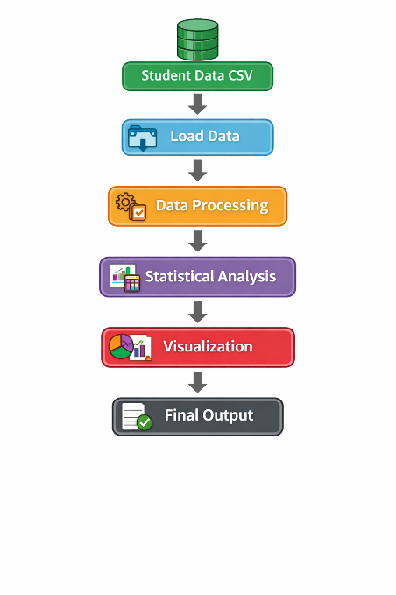

6. Module Description
🔹 6.1 Data Loading (01_load_data.R)
Description:
- Reads the dataset from CSV file
- Displays column names
- Shows first few records
- Checks structure of dataset
Purpose:
To ensure the dataset is loaded correctly and ready for processing
Code:
df <- read.csv("data/student_marks.csv")
# Display column names
print(colnames(df))
# Display first few rows
head(df)
# Check structure
str(df)

6.2 Data Processing (02_process_data.R)
Description:
- Converts column names to lowercase
- Calculates total marks
- Calculates average marks
- Assigns grades based on average
Purpose:
To clean and transform raw student data into meaningful format
Code:

library(dplyr)
process_data <- function(df) {
# Convert column names to lowercase
colnames(df) <- tolower(colnames(df))
# Calculate total, average and grade
df <- df %>%
mutate(
total = g1 + g2 + g3,
average = total / 3,
grade = case_when(
average >= 16 ~ "A",
average >= 14 ~ "B",
average >= 12 ~ "C",
average >= 10 ~ "D",
TRUE ~ "F"
)
)
return(df)
}

6.3 Statistical Analysis (03_analysis.R)
Description:
- Calculates mean, median, standard deviation
- Ranks students based on average marks
- Identifies top 3 students
- Identifies lowest performer
- Saves results into CSV file

Purpose:
To analyze student academic performance and identify insights

Code:
library(dplyr)
analyze_data <- function(df)
cat("📊 Statistical Analysis\n")
# Statistical values
cat("Mean:", mean(df$average, na.rm = TRUE), "\n")
cat("Median:", median(df$average, na.rm = TRUE), "\n")
cat("SD:", sd(df$average, na.rm = TRUE), "\n\n")
# Ranking
df <- df %>%
arrange(desc(average)) %>%
mutate(rank = row_number())
# Top 3 students
cat("🏆 Top 3 Students:\n")
print(head(df, 3))
# Lowest performer
cat("\n⚠️ Lowest Performer:\n")
print(tail(df, 1)
# Save output
write.csv(df, "output/final_results.csv", row.names = FALSE)
return(df)

6.4 Data Visualization (04_visualization.R)
Description:
- Generates histogram for marks distribution
- Creates bar chart for top students
- Creates pie chart for grade distribution
- (Optional) scatter plot for study time vs marks
Purpose:
To visually represent student performance for better understanding

Code:
library(ggplot2)
library(dplyr)
plot_data <- function(df)
# Histogram
p1 <- ggplot(df, aes(x = g3)) +
geom_histogram(fill = "skyblue", color = "black") +
labs(title = "Marks Distribution")
ggsave("output/histogram.png", plot = p1)
# Top 10 students
top10 <- df %>%
arrange(desc(average)) %>%
head(10)
p2 <- ggplot(top10, aes(x = reorder(name, average), y = average)) +
geom_bar(stat = "identity", fill = "orange") +
coord_flip() +
labs(title = "Top 10 Students")
ggsave("output/top10.png", plot = p2)

# Piechart (Grade distribution)
grade_count <- as.data.frame(table(df$grade))
colnames(grade_count) <- c("grade", "count")
p3 <- ggplot(grade_count, aes(x = "", y = count, fill = grade)) +
geom_bar(stat = "identity", width = 1) +
coord_polar("y") +
theme_void() +
labs(title = "Grade Distribution")
ggsave("output/pie_chart.png", plot = p3)
# Optional scatter plot
if ("studytime" %in% colnames(df)) {
p4 <- ggplot(df, aes(x = studytime, y = g3)) +
geom_point(color = "red") +
labs(title = "Study Time vs Marks")
ggsave("output/study_vs_marks.png", plot = p4)
}
print("Plots generated successfully!")
}

7. Key Techniques Used in Student Performance Analysis System
🔹 Data Validation
Ensures the dataset is not empty and verifies that required columns (Name, G1, G2, G3) are present and contain valid data.
🔹 Data Processing
Standardizes column names and prepares student data for analysis by cleaning and organizing the dataset.
🔹 Total & Average Calculation

Computes the total marks and average marks for each student based on subject scores.
🔹 Grade Classification
Assigns grades (A, B, C, D, F) to students based on their average marks to categorize performance levels.
🔹 Statistical Analysis
Calculates key statistical measures such as:
- Mean
- Median
- Standard Deviation
These help in understanding overall class performance.
🔹 Ranking System
Ranks students based on their average marks to identify their position in the class.

8. Output of Student Performance Analysis System
🔹 Execution Output
Starting Student Marks Analysis Project...
Attaching package: 'dplyr'
The following objects are masked from 'package:stats':
filter, lag
[1] "Name" "G1" "G2" "G3"
'data.frame': 30 obs. of 4 variables:
$ Name: chr "Arun" "Priya" "Karthik" ...
$ G1 : int 15 17 16 ...
$ G2 : int 16 18 17 ...
$ G3 : int 17 18 18 ...
===== DATA PROCESSING =====
✔ Total and Average calculated successfully
✔ Grades assigned based on average
===== DESCRIPTIVE STATISTICS =====

Median Average: 14
Standard Deviation: 2.85
===== STUDENT RANKING =====
🏆 Top 3 Students:
name g1 g2 g3 total average grade rank
1 Arun 18 17 19 54 18.0 A 1
2 Priya 17 18 18 53 17.67 A 2
3 Karthik 16 17 18 51 17.0 A 3
⚠️ Lowest Performer:
name g1 g2 g3 total average grade rank
30 Ravi 8 9 7 24 8.0 F 30
===== FILE OUTPUT =====
✔ Final results saved to: output/final_results.csv
===== VISUALIZATION =====
✔ Histogram generated: output/histogram.png
✔ Top 10 chart generated: output/top10.png
✔ Pie chart generated: output/pie_chart.png
✔ Plots generated successfully!
🎉 Project Completed Successfully!
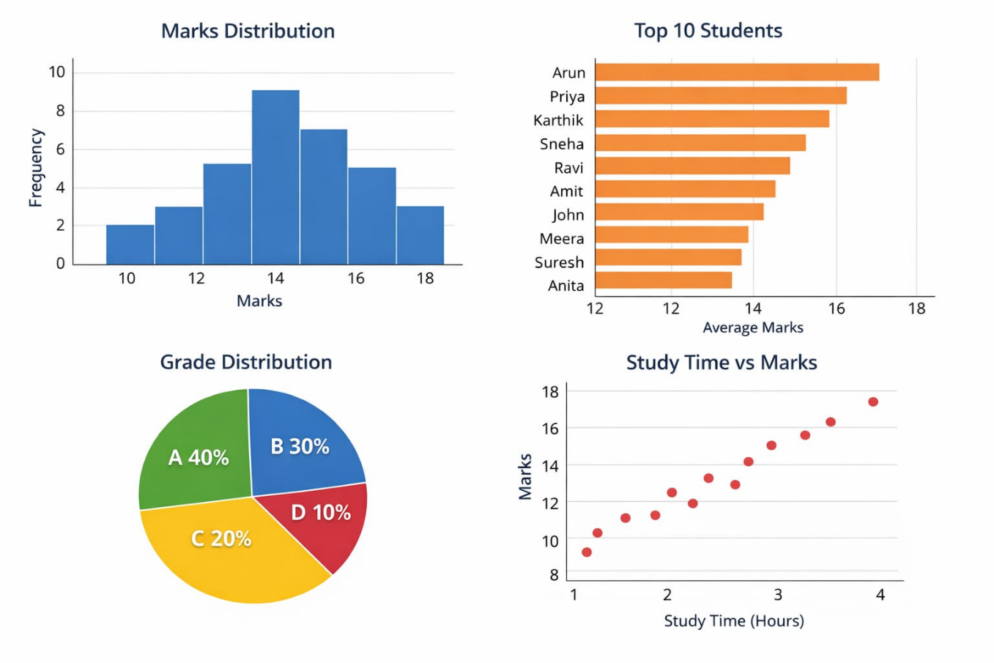

9. Conclusion of Student Performance Analysis System
The project successfully implements a Student Marks Analysis System using R programming with statistical and data processing techniques. The system efficiently analyzes student performance by calculating total marks, average, and assigning grades.
The automation of the analysis process reduces manual effort and improves accuracy. By applying statistical methods and visualization techniques, the system provides meaningful insights into student performance.
🔹 Key Findings:
- Student performance can be evaluated effectively using statistical measures
- Ranking system helps in identifying top and low performers
The system can be further enhanced by integrating advanced technologies such as machine learning for predictive analysis.

10. Future Enhancements of the System
The current system can be improved with the following features:
🔹 Machine Learning Integration
- Use ML models to predict student performance
- Identify students at risk of failure
🔹 Subject-wise Analysis
- Analyze performance for each subject separately
- Provide detailed insights per subject
🔹 Interactive Dashboard
- Develop a user-friendly dashboard using R Shiny
- Allow dynamic data visualization

